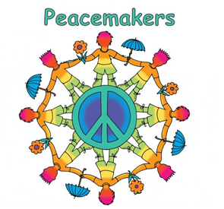
Peacemakers Project

Your Name: ___________________________________________

Name of person: _______________________________________

Birthplace of person: _______________________________________

Birth date of person: _______________________________________

In what way is this person a peacemaker? ________________________

__________________________________________________________________

__________________________________________________________________

Tell three interesting facts about this person:

- _____________________________________________________________

_____________________________________________________________

- _____________________________________________________________

_____________________________________________________________

- _____________________________________________________________

_____________________________________________________________
Please include a drawing or photo of your peacemaker.

