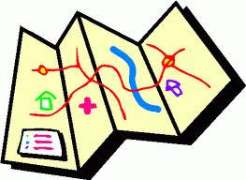
Map Making Project

Dear Parents,
We are currently studying maps in the geography area of our classroom. As a part of this study, we are learning about different kinds of maps and their parts, such as the Montessori continent puzzle map on which each of the seven continents are represented by a different color. It is not only important to have a knowledge of these places, but to be able to identify and describe places in our immediate environments as well. Therefore this month’s project is for the kindergarten students to make a map of his/her own room.
Here’s what to do:
Your child is to make a map of his/her bedroom. It should be on paper that is at least 8 ½ by 11” paper. You may make it larger (poster board, for example).
It should have a title and your child’s name.
The map should be colored (crayons, markers, paints, etc.), and it should have a simple key.
Each student should write sentences describing how they made their map, including the sequence of events, and who helped with the project. This should be done in your child’s own words. Be sure to encourage inventive spelling. You may assist your child with the writing, however, they should do as much as possible on their own.
A rubric is included. Please read it carefully. It will help you make sure that your child’s map meets the expectations.
This project will be due Monday, November 3, 2014.

