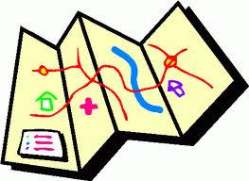
Student’s Name: ___________________________________________ Date: __________________
Map Making Project Rubric
Score | Criteria | Comments
3 | - Project turned in on time.  - Title and student’s name are at the top of the map.  - Map shows at least five or more items in the child’s bedroom (door, window, bed, table, lamp, desk, etc.)  - Map key shows a symbol for each of the items in the room.  - Very colorful and clean looking.  - All handwriting is neat and legible.  - Able to tell about it. | ______________________  ______________________  ______________________  ______________________
2 | - Project turned in on time.  - Title and student’s name are at the top of the map.  - Map shows at least four items in the child’s bedroom.  - Map key shows a symbol for almost all of the items in the room.  - Some color  - Most handwriting is neat and legible.  - Not able to clearly share with group/project turned in late. | ______________________  ______________________  ______________________  ______________________
1 | - Project turned in late  - Title and student’s name are not at the top of the map  - Map shows less than three items in the child’s room.  - Map key is missing or symbols are incomplete  - Limited or no use of color  - Little of the handwriting is neat and legible.  - Did not participate in sharing with group/unable to clearly tell about it. | ______________________  ______________________  ______________________  ______________________

