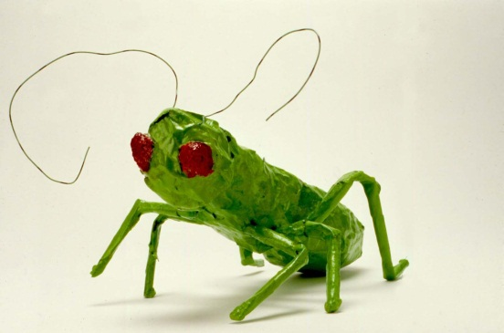
Your Name: ___________________________________________

What insect did you choose? | __________________________
Does it have wings? | __________________________

Something I have learned about this insect is:

- _____________________________________________________________

_____________________________________________________________

- _____________________________________________________________

_____________________________________________________________

- _____________________________________________________________

_____________________________________________________________

