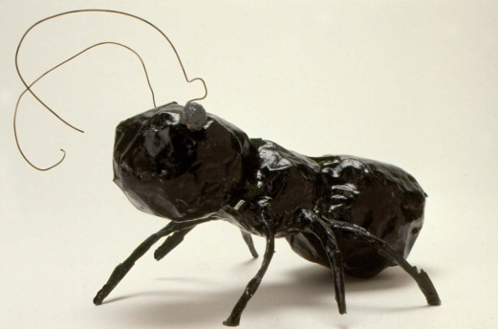

Student’s Name: ___________________________________________ Date: __________________

Insect Model Rubric

Score | Criteria | Comments
3 | - Model turned in on time.  - 3 facts provided in complete sentences/good description of insect  - Model shows the 3 basic body parts of the insect (head, thorax, and abdomen), along with antennae, wings and 6 legs.  - All handwriting is neat and legible.  - Able to tell about it. | ______________________  ______________________  ______________________  ______________________
2 | - 2-3 facts provided/description of insect  - Model shows 2-3 basic parts of the insect, along with antennae, wings and 6 legs.  - Most handwriting is neat and legible.  - Not able to clearly share with group/model turned in late. | ______________________  ______________________  ______________________  ______________________
1 | - Model turned in late  - Only 1 fact provided/little or no description of insect  - Model only shows 1 basic part of the insect, along with inappropriate number of antennae, wings/ legs.  - Little of the handwriting is neat and legible.  - Did not participate in sharing with group/unable to clearly tell about it. | ______________________  ______________________  ______________________  ______________________

