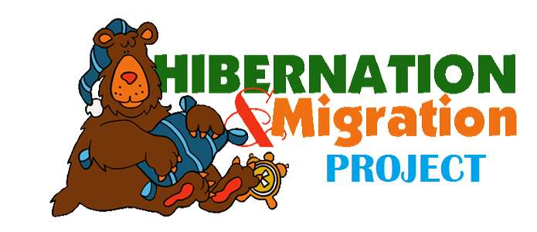
Your Name:___________________________________________

What animal did you choose? | __________________________
Does this animal hibernate or migrate? | __________________________

Something I have learned about this animal is:
- _____________________________________________________________

_____________________________________________________________

- _____________________________________________________________

_____________________________________________________________

- _____________________________________________________________

_____________________________________________________________

Please include a drawing or photo of your animal.

