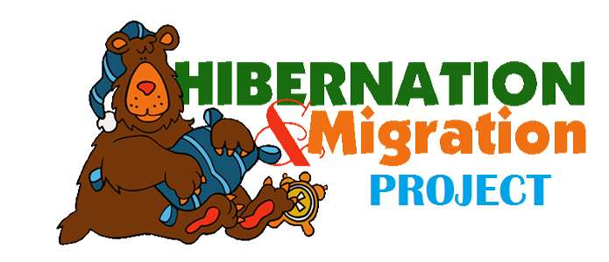

Student’s Name: ___________________________________________ Date: __________________

Hibernation & Migration Project Rubric

Score | Criteria | Comments
3 | - Project turned in on time.  - 3 facts provided in complete sentences/good description of animal  - Very colorful illustration/picture and clean looking.  - All handwriting is neat and legible.  - Able to tell about it. | ______________________  ______________________  ______________________  ______________________
2 | - Project turned in on time.  - 2-3 facts provided/description of animal  - Some color in illustration/picture included  - Most handwriting is neat and legible.  - Not able to clearly share with group/project turned in late. | ______________________  ______________________  ______________________  ______________________
1 | - Project turned in late  - Only 1 fact provided/little or no description of animal  - Limited or no use of color/no picture  - Little of the handwriting is neat and legible.  - Did not participate in sharing with group/unable to clearly tell about it. | ______________________  ______________________  ______________________  ______________________

