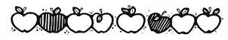
Apple Tasting Project

Your Name:___________________________________________

What apples did you taste?
__________________________  __________________________  __________________________  __________________________ | Draw a picture of your favorite apple.
What was your favorite apple?

_____________________________
Tell why this was your favorite. Use descriptive words. How did it taste, feel, smell?
__________________________________________________________________
__________________________________________________________________
__________________________________________________________________
__________________________________________________________________

